**64. Spring REST - CRUD Database Project - Get Customers**

**Application Interaction**:

Here we will make a get request as "/api/customers" and then we will return JSON, which is a list of the customers.

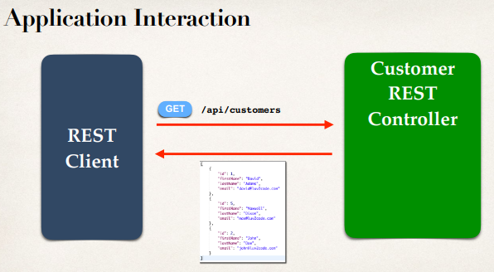

**Application Architecture**:

We will reuse the existing codes of our previous project. We will make use of our CustomerService, and CustomerDAO and that’s all our previous MVC web project.

We will add only the "**CustomerRestController**" here.

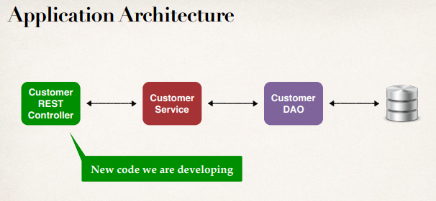

**Development Process**:

1. Create Customer REST Controller
2. Autowire CustomerService
3. Add mapping for GET /customers

**CustomerRestController.java**:

**package** com.ruhul.springdemo.rest;

**import** java.util.List;

**import** org.springframework.beans.factory.annotation.Autowired;

**import** org.springframework.web.bind.annotation.GetMapping;

**import** org.springframework.web.bind.annotation.PathVariable;

**import** org.springframework.web.bind.annotation.RequestMapping;

**import** org.springframework.web.bind.annotation.RestController;

**import** com.ruhul.springdemo.entity.Customer;

**import** com.ruhul.springdemo.service.CustomerService;

@RestController

@RequestMapping("/api")

**public** **class** CustomerRestController {

// autowire the CustomerService => inject the dependency

@Autowired

**private** CustomerService customerService;

// add mapping for GET /customers

@GetMapping("/customers")

**public** List<Customer> getCustomers() {

**return** customerService.getCustomers();

}

}

**Get Single Customer**:

For a single customer we have to make a get request as " **/api/customers /{customerId}** " and then we will return JSON, which is a single customer.

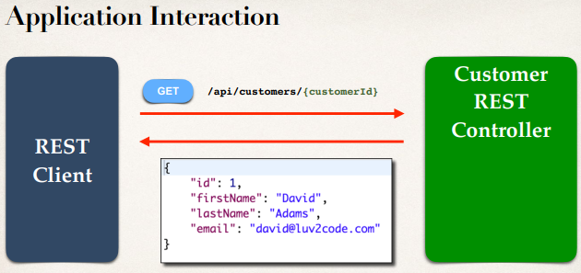

@RestController

@RequestMapping("/api")

**public** **class** CustomerRestController {

...

// add mapping for GET /customers/{customerId}

@GetMapping("/customers/{customerId}")

**public** Customer getCustomer(@PathVariable **int** customerId) {

Customer theCustomer = customerService.getCustomer(customerId);

**return** theCustomer;

}

}

64. Spring REST - CRUD Database Project - Get Customers